**Enhanced Health in Care Homes V 2.0**

Resident of Concern Form  
*for homes*

**Referring into the EHCH Team**

Ensure to refer into the EHCH team following the inbound referral resident-of-concern algorithm below, to ensure residents receive the most appropriate/timely intervention.

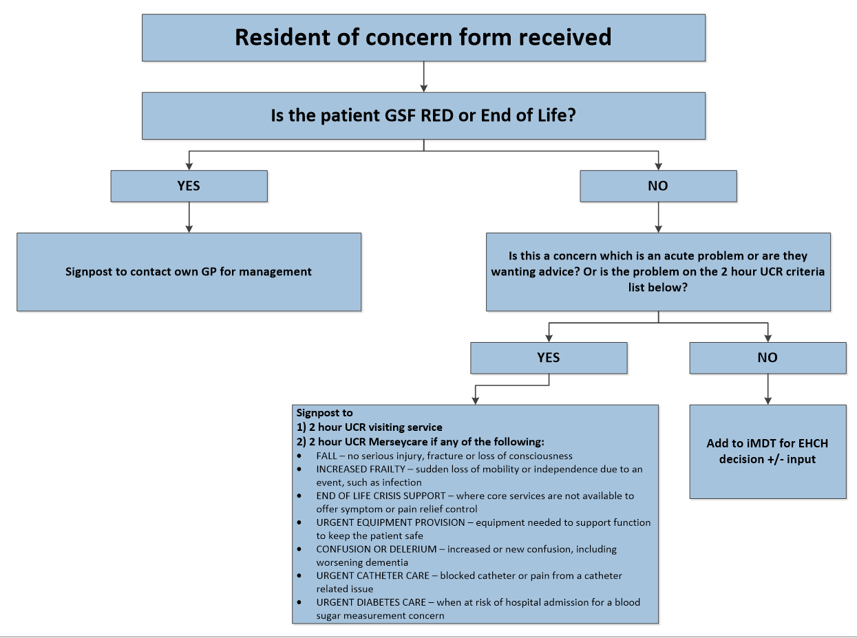

**Referrer Information**

|  |  |
| --- | --- |
| Care Home Name (inc. unit) |  |
| Care Home Address |  |
| Care Home Access Code (if required) |  |
| Name of Person Referring |  |
| Role of Person Referring |  |
| Your Contact Tel No. |  |
| Date of Referral |  |
| Date Resident Began Residing in Home |  |

**Resident/Patient Information**

|  |  |
| --- | --- |
| Resident Full Name |  |
| Resident Date of Birth |  |
| Resident’s Registered GP Surgery |  |

**Nature of your concern**

|  |
| --- |
|  |

**Onward Referral**

Send completed referral forms via secure e-mail to the relevant team.

SOUTHPORT TEAM  
Key Information:  
Monday-Friday, 9am - 5pm  
01704 395807

**Referral / Contact email:** [sfhealth.carecoordinator@nhs.net](mailto:sfhealth.carecoordinator@nhs.net)

FORMBY TEAM:  
Key Information:  
Monday-Friday, 9am - 5pm  
01704 835155

**Referral / Contact email:** [formby.carehometeam@nhs.net](mailto:formby.carehometeam@nhs.net)